Festival of Bar’itok Booking forms

Name:
Address
Postcode

Telephone Number
Mobile Number
Email Address

Medical Information
Age if under 16
Emergency Contact

I enclose payment for -

Booking Price | £15.00
Please Tick this box if you would like the vegetarian option

I agree to abide by the rules and issued by the event organizer for site and personal safety
(If under 16, parent or guardian must sign)

Signed: |  | Date:

Players
- Event is taking place on the 21st of February
- Tickets are £15 for the night. This is to pay for the renting of the bar and the meal provided. A vegetarian option is available on request.
- Please note that the event will begin at 6:30pm Players will not be allowed on site until this time.
Monsters
- This is purely a social event with no plot running. Therefore no monster will be needed.
Queries?
If you have any queries or questions regarding the event, contact Peter Godfrey at pmtg@thealashans.co.uk
Please Note:
- The event is being held as an in-character social event in Bugmans Brewery, Nottingham. The ticket price is to pay for the food. A vegetarian option is available on request.
- This is an unsanctioned event. Therefore, no weapons will be allowed into the building, and no magic / special abilities will work. Other lammies will only be permitted if they are there for role-play reasons.
- Please note that this is unsanctioned, and no combat or killing will be allowed. There will also be no Plot running at the meeting.

Cheques and/or postal orders should be made payable to Peter Godfrey.

Please note that the final booking date is the 8th of February, and all cheques must be received by then.

To book for the event you need to send your booking form, payment to: -

Peter Godfrey,
11 Lewis Street,
Treforest, Pontypridd,
South Wales,

CF37 1BZ

The Festival of Bar’itok
Bugman’s Brewery, Nottingham.
On behalf of Doyen Gworshkoff of the Alashans, you are hereby invited to Ralimar Hall in the area of New Port to celebrate the festival of Bar'itok. This festival is being held in the honour of the Unicorn Ancestors, most notably Cadrus Cornus, father of the Unicorns and Queen Adelena. It will also be a time to finally honour the names and the memories of our fallen comrades and friends. The area has been well fortified from attack, and to keep the evening peaceful, weapons will be stowed outside. The celebrations will be a rare time of relaxing, socializing and drinking among friends.
The invitation is extended to not only member of the faction both past and present, but also friends of the faction and to any creature of any guild, faction or other group that comes with peaceful intentions.

Rules and Regs
- The event organizers or any persons so appointed by event organizers cannot be held personally liable or responsible for any injury or damage to any individual participating in the event.
- The event organizers cannot be held responsible for any damage to, loss or theft of any personal or communal property during any the event.
- The organizers will expel any individual engaged in illegal, defamatory or dangerous practices during the event ‘it’s funny is not an excuse!

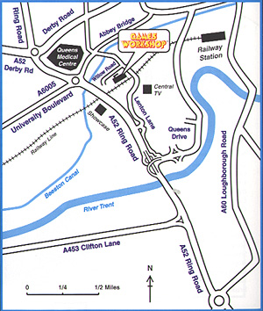

The site of Bugmans Bar is located in the Games Workshop Warhammer World as indicated on the map above.

