The Unicorn Faction booking form.

Name:
Address
Postcode

Telephone Number
Mobile Number
Email Address

Medical Information
Age if under 16
Emergency Contact
Tick if Vegetarian

I enclose payment for -

Booking before 30th September | £35.00
Booking received After 30th September | £40.00
Monster / child under 14 / staff | FREE
Indoor quiet (ish) accommodation | £5.00
Indoor ic accommodation (bunk bed in ic hall, will be ic and noisy until after time out) | £5.00

Total ________

I agree to abide by the rules and guidelines in the Lorien Trust system and those issued by the event organizer for site and personal safety
(If under 16, parent or guardian must sign)

Signed: |  | Date:

For Office Use Only
Plyr #? | : |  | Staff? | :
NPC? | : |  | Ch,ad | :
Mns# | : |  | Ind/out | :
Rcv’d | : |  | Ack’d | :
Cd Spec | :

The Unicorn Faction Character Sheet

Character Name
Race
Rank in Group or Faction
Group Name
Faction
Faction Rank Title (If Any) [1]
Group Leader (Real Name)
Group Organiser (If different from above)
Are you a carded “Special”? [2]
Are you an NPC

1. The position or job that you hold in your Faction i.e. Gimp Husband or Demon, etc.
2. If you have a “Special Character” card, please include a copy of it with your booking and bring it to the event with you, NO CARD - NO EFFECT. See the ‘Rules & Regulations’

Delete as Applicable: - Combat / Non Combat
Civilian / Warrior / Guildsman / Magician / Incantor

You have 17 points to spend on your skills. Please indicate the amount of points spent on each skill.

Small Weapons [0] |  | Spell casting I [5]
One Handed Weapons [1] |  | Spell casting II [8]
Two Handed Weapons [3] |  | Spell casting III [20]
Projectile Weapons [4] |  | Incantation I [5]
Missile Weapons [1] |  | Incantation II [8]
Shield Use [2] |  | Incantation III [20]
Light Armour [2] |  | Ritual Magic [1-8]
Medium Armour [3] |  | Contrib. To Ritual [1]
Heavy Armour [4] |  | Bind Wounds [1]
Body Development [6] |  | Physician [3]
Ambidexterity [2] |  | Invocation [3]
Literacy [1] |  | Sense Magic [2]
Numeracy [0] |  | Poison Lore [5]
Make/Read Maps [1] |  | Potion Lore [3]
Evaluate [1] |  | Recognise Forgery [2]
Healing [7-17]

OSP’S: (Only Valid if shown on LT Character Card)

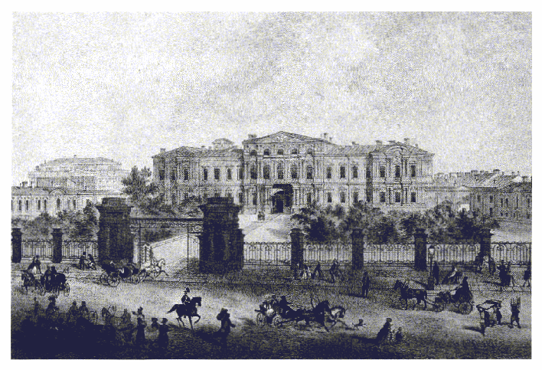

Kibblestone International Scout Camp
Oulton, Stone
Staffordshire
ST15 8TD
Friday 11th November – Sunday 13th November 2005

A UNICORN SANCTIONED EVENT in association with Burning Ambitions

Unicorn Winter Parliament

The Royal Family would like to invite all members of the Unicorn Nation to a Parliament, to be held in the grounds of the Palace at Capital City.

The past year has wrought many changes. Mephias has been defeated, but at the cost of the loss of Alasha. The volcano on Illyria erupted, sinking the land surrounding it and claiming many lives. Those rescued were relocated to Grind, where tragedy struck once again when the conclave attacked Mauritanja and caused the sinking of both Grind and Shipyard Isle. The destruction is too widespread for us to ever know the true death toll, or account for all we have lost. Added to that, Akasha the Betrayer still walks among us, whilst tales of sinister events are relayed to us from Beast Isle. Last, but by no means least, the Tainted still watch for an opening and strike where they can.

But we need not sit back like helpless children. We invite you all to meet with us and share knowledge, so that we may be better prepared in the year to come. The Palace and Ritual Circle will remain under a strict security blanket in order to protect the resources held within the Capital. But we shall make available to you the meeting hall and the Temple within the Palace grounds. Both are a short walk from the Capital City Transport circle and offer accommodation and a chance to enjoy the Palace Gardens.

We hope as many of you as possible will join us there.

Prince Regent Vadek, Princess Rowan and Knight General Duvall.

Players

Tickets are £35 before 30th September, after which the fee is £40. Please add £5 if you want indoor accommodation, and this has to be first come first served. So book early to avoid disappointment. We will not be accepting on the gate bookings, excepting individual arrangements as per usual. Children under 14 attend the event for free, but must fill in the booking form and get a parent or guardian to sign.

Monsters

The first 20 monsters to book attend for free and will get two meals a day. Thereafter monsters will still attend the event for free, but no food will be provided. Monsters will have to pay for indoor accomadation.

Queries?

If you have any queries or questions regarding the event, either contact Catherine on the number overleaf, or email ca_hoare@yahoo.co.uk

Costs

The cost of site hire has risen dramatically over the last couple of years, and it is becoming more and more difficult for us to make money to reinvest in the faction. Hence we have had to increase the attendance cost, add the charge for indoor accommodation, and put a limit on the number of monsters we feed for free. We apologise for this, but can find no other way to secure the future of our sanctioned events.

And please note, we cannot accept unsigned booking forms, or forms where the emergency contact details have not been completed.
Booking Information

Cheques and/or postal orders should be made payable to Unicorns.
To book for the event you need to send you’re booking form, payment and any relevant laminates (Any you want to use on site MUST be seen by event organiser) to: -

Catherine Hoare

Paragon
Orchard Marina
School Road
Rudheath
Northwich

Cheshire
CW9 7RG

Enquiries should be directed to

EVENT ORGANISER

Catherine Hoare 07714327195
ca_hoare@yahoo.co.uk

Rules and Regulations of The Unicorn Faction.

- The Unicorn Faction or any persons so appointed by The Unicorn Faction cannot be held personally liable or responsible for any injury or damage to any individual participating in any The Unicorn Faction event.
- The Unicorn Faction cannot be held responsible for any damage to, loss or theft of any personal or communal property during any The Unicorn Faction event.
- The Unicorn Faction are NOW operating a strict ‘NO CARD. NO EFFECT’ policy. Any and all special items, poisons etc must be disclosed prior to booking. There are NO exceptions to this rule.
- LRP is a potentially dangerous hobby and I agree to act in a reasonable and safe manner during any LRP event.
- I understand and agree that The Unicorn Faction reserves the right to refuse admission or participation in any event or part of an event to any individual at any time. The organisers are not obliged to give any reason or explanation for such a decision, but one can be supplied after a request in writing.
- Metal weapons or tools are NOT to be carried on site. Camping knives may only be carried in direct proximity to allocated camping areas.
- The organisers will expel any individual engaged in illegal, defamatory or dangerous practices during the event ‘it’s funny is not an excuse!’
- The Organisers decision is final in all disputes.

The Unicorn Faction and Unicorn Faction Command use the Lorien Trust LRP version 2.0 Rules System. The Lorien LRP System is copyright to the Lorien Trust 1996.

